**Project 3: Smart Beta Portfolio and Portfolio Optimization**

Smart beta has a broad meaning, but we can say in practice that when we use the universe of stocks from an index, and then apply some weighting scheme other than market cap weighting, it can be considered a type of smart beta fund.

A Smart Beta portfolio generally gives investors exposure or "beta" to one or more types of market characteristics (or factors) that are believed to predict prices while giving investors a diversified broad exposure to a particular market.

Smart Beta portfolios generally target momentum, earnings quality, low volatility, and dividends or some combination. Smart Beta Portfolios are generally rebalanced infrequently and follow relatively simple rules or algorithms that are passively managed. Smart Beta portfolios are generally long-only, they do not short stocks.

**Part 1: Smart Beta Portfolio**

In Part 1 of this project, you'll build a portfolio using dividend yield to choose the portfolio weights. A portfolio such as this could be incorporated into a smart beta ETF. You'll compare this portfolio to a market cap weighted index to see how well it performs.

**Index Weights**

Index weights are based off of dollar volume weights

Index_weights = def generate_dollar_volume_weights(close, volume):

* Step 1: dollar_volume = multiply Close Price by Volume for each date and stock ticker
* Step 2: divide each cells dollar volume by the total dollar volume for every ticker on that date to get weight

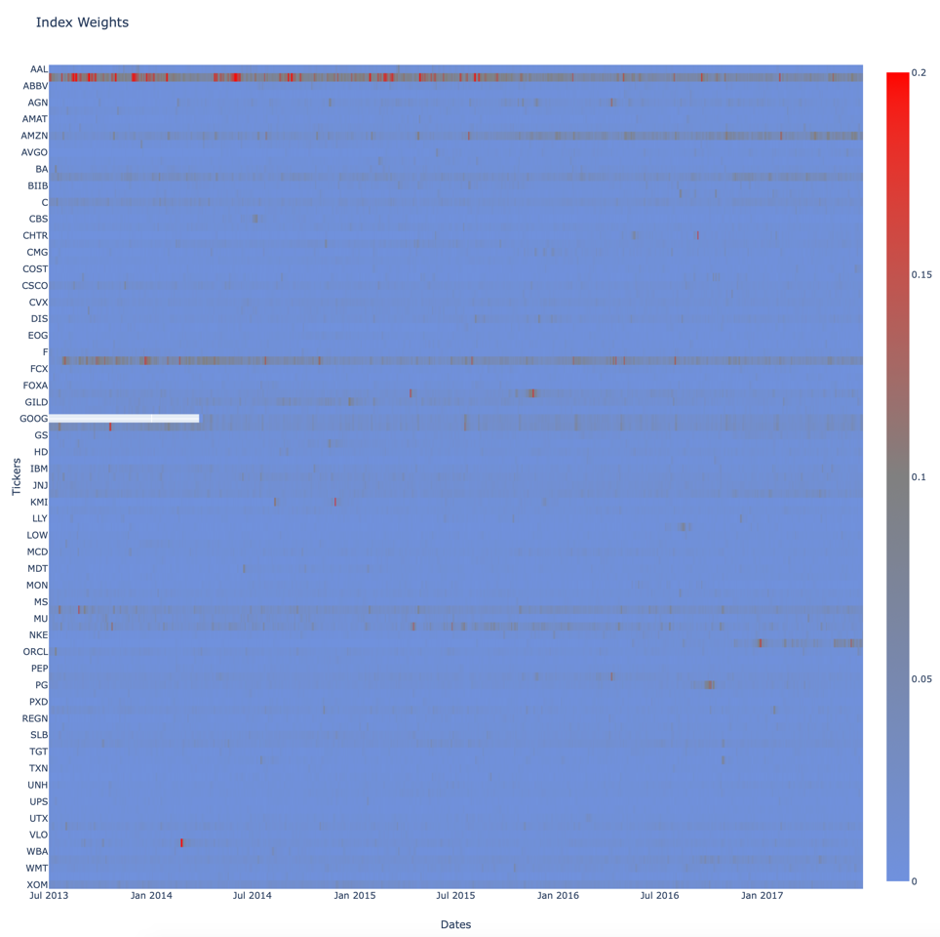

**Portfolio Weights**

Return the weights for each stock based on its total dividend yield over time. This is similar to generating the weight for the index, but it's using dividend data instead.

def calculate_dividend_weights(dividends):

* Step 1: sum the total dividend amount for each ticker
* Step 2: sum the total dividend amount per date across tickers
* Step 3: divide the cumulative dividend amount per ticker on a date by the total cumulative dividends for all tickers on date

etf_weights = calculate_dividend_weights(dividends)

**Returns**

Since we're not dealing with volatility, we don't have to use log returns.

def generate_returns(prices):

* Step 1: difference between date's return and previous date's return / previous date's return

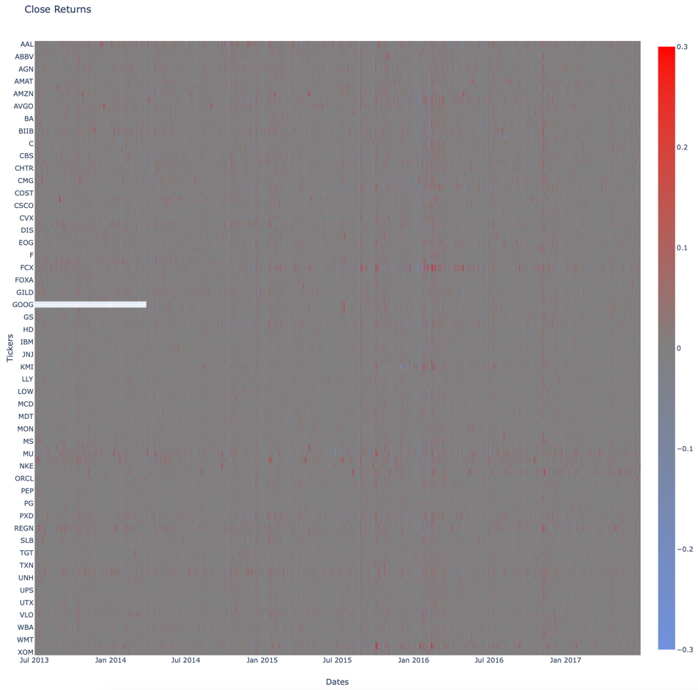

**Weighted Returns**

With the returns of each stock computed, we can use it to compute the returns for an index or ETF using the returns and weights.

def generate_weighted_returns(returns, weights):

* Multiply returns x weights

index_weighted_returns = generate_weighted_returns(returns, index_weights)

etf_weighted_returns = generate_weighted_returns(returns, etf_weights)

**Cumulative Returns**

To compare performance between the ETF and Index, we're going to calculate the tracking error. Before we do that, we first need to calculate the index and ETF comulative returns

def calculate_cumulative_returns(returns):

add returns across tickers for date, add 1 as base amount, multiply across dates cumulatively

index_weighted_cumulative_returns = calculate_cumulative_returns(index_weighted_returns)

etf_weighted_cumulative_returns = calculate_cumulative_returns(etf_weighted_returns)

**Tracking Error**

In order to check the performance of the smart beta portfolio, we can calculate the annualized tracking error against the index.

𝑇𝐸 = √252 ∗ 𝑆𝑎𝑚𝑝𝑙𝑒𝑆𝑡𝑑𝑒𝑣(𝑟𝑝−𝑟𝑏)

def tracking_error(benchmark_returns_by_date, etf_returns_by_date):

* rp = etf_returns_by_date
* rb = benchmark_returns_by_date
* tracking_error = …

smart_beta_tracking_error = tracking_error(np.sum(index_weighted_returns, 1), np.sum(etf_weighted_returns, 1

Smart Beta Tracking Error: 0.10%

**Part 2: Portfolio Optimization**

Now, let's create a second optimized ETF portfolio that will show to investors how well our fund tracks its index.

By minimizing a linear combination of both the portfolio risk and distance between portfolio and benchmark weights, we attempt to balance the desire to minimize portfolio variance with the goal of tracking the index.

Also for coding purposes, can be written as:

* Portfolio variance is 𝜎2𝑝 = 𝐱𝐓𝐏𝐱
* Where 𝑚 is the number of stocks in the portfolio
* 𝜆 is a scaling factor that you can choose
* *indexWeight* is market cap weighted index from Part 1.
*  is the L2 Norm

Implement get_covariance_returns to calculate the covariance of the returns. We'll use this to

calculate the portfolio variance.

We can also use covariance to calculate correlation, which is a scaled version of covariance.

covariance_returns_correlation = np.linalg.inv(np.diag(np.sqrt(np.diag(covariance_returns))))

def get_optimal_weights(covariance_returns, index_weights, scale=2.0):



**Optimized Portfolio**

Using the get_optimal_weights function, let's generate the optimal ETF weights without rebalancing. We can do this by feeding in the covariance of the entire history of data. We also need to feed in a set of index weights. We'll go with the average weights of the index over time.

raw_optimal_single_rebalance_etf_weights = get_optimal_weights(covariance_returns.values, index_weights.iloc[-1])

With our ETF weights built, let's compare it to the index returns:

**Rebalance Portfolio Over Time**

The single optimized ETF portfolio used the same weights for the entire history. This might not be the optimal weights for the entire period. Let's rebalance the portfolio over the same period instead of using the same weights. Rebalancing is the process of realigning the weightings of a portfolio of assets.

**Portfolio Turnover**

With the portfolio rebalanced, we need to use a metric to measure the cost of rebalancing the portfolio. Implement get_portfolio_turnover to calculate the annual portfolio turnover, which is a measure of how frequently assets within a fund are bought and sold by the managers.



print(get_portfolio_turnover(all_rebalance_weights, shift_size, len(all_rebalance_weights) - 1))

16.7% portfolio turnover